Please complete your application below. We promise to legitimately use the information you provide to manage your volunteer involvement with Sustrans, including progressing your application. We will delete your information five years after the end of your volunteering with us. If you are unsuccessful, your application form will be deleted/shredded.
Volunteer application form

We will share contact details with relevant Sustrans staff or volunteers to facilitate communication so that we can work together more effectively. Sustrans is committed to protecting your privacy and personal data. For more information visit www.sustrans.org.uk/privacy.

This form is for volunteers who have responsibility to carry out or lead agreed regular tasks that help and support Sustrans.

Personal information
Title: |  | First name: |  | Surname:
Address: |  |  |  | Telephone:
 |  |  |  | Mobile:
Post code: |  |  |  | Email:
Are you aged 18 or over? | ☐ Yes ☐ No (click on box to tick)  If ‘no’, please also submit a young person consent form.

2. Getting involved
Which volunteer role are you applying for? | ☐ Walk leader – Expectation for completion of a minimum of 30 hours certified free training, including Mediation Level 1 - Forth Meadow Community Greenway  ☐ Ride leader – Expectation for completion of a minimum of 30 hours certified free training, including Mediation Level 1 - Forth Meadow Community Greenway
How did you hear about Sustrans’ volunteer programme on the Forth Meadow Community greenway? | ☐ Sustrans staff ☐ Sustrans volunteer ☐ Friend or family ☐ Employer ☐ Local volunteer/community centre ☐ Sustrans poster or leaflet ☐ Local press, TV or radio ☐ National press, TV or radio ☐ Sustrans website ☐ External website ☐ Social media ☐ Other, please specify
Depending on your role, you might need a hi-vis vest or t-shirt for your volunteer activities. Please indicate which size you would require: ☐ S ☐ M ☐ L ☐ XL ☐ XXL

Formal references – provide details of TWO character referees (not a relative or friend).
If you have any difficulty completing this section of the form, please leave it blank as this can be discussed after your application has been received.
Name: |  | Relationship:
Email or postal address:
Name: |  | Relationship:
Email or postal address:
Volunteer application form

4. Additional support and adaptations needed to carry out this role
Do you require any additional support or adaptions in order to carry out this volunteering role? | ☐ Yes ☐ No
If ‘yes’ please provide details below (use a separate sheet if necessary)

5. Criminal convictions declaration
Criminal convictions declaration - this will be kept strictly confidential

Do you have any convictions which are unspent under the Rehabilitation of Offenders Act 1974? Yes ☐ No ☐

Having a conviction doesn’t necessarily prevent you from volunteering with Sustrans. When we talk about your application we can discuss any convictions then.

6. Receiving Sustrans updates
You will receive volunteering updates. Please tick this box if you want to stay up to date with the latest news, fundraising, events, ideas for rides and walks on the National Cycle Network, offers and updates on our work from across the UK. | ☐ Yes, I’d like to receive the Sustrans monthly e-newsletter

7. Your declaration and partnership with Sustrans
When you volunteer with Sustrans you need to sign up to our volunteer partnership agreement. This outlines what you can expect from us and what we expect from you. |  |  | ☐ I have read and agree to ‘Your Partnership with Sustrans’
Sustrans works in partnership with Belfast City Council and Intercomm for the Forth Meadow Community greenway volunteer project and we will share your contact details (name, email address, telephone number and address) to enable them to contact you in relation to volunteering on the greenway specifically.
Please tick: | ☐ The information I have provided may be shared as described above.
The information I have provided on this application form is true and complete. I understand that any information later discovered to be incorrect may result in the ending of my volunteer role.
Signature: |  | Date:

Find out more about Belfast City Council’s PEACE IV programme at www.belfastcity.gov.uk/peaceiv

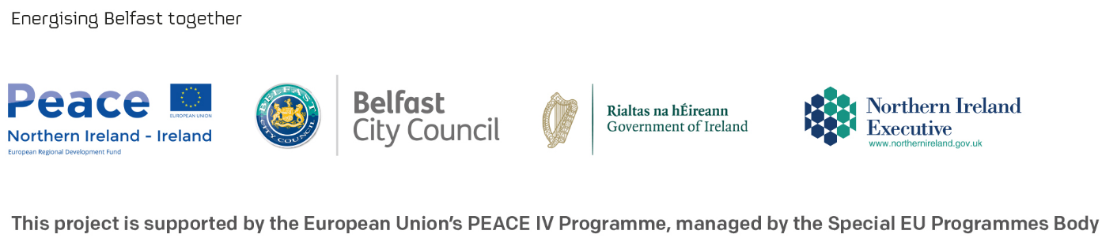

Sustrans wants to meet the aims and commitments set out in its equality, diversity and inclusion policy. This includes not discriminating under the Equality Act 2010, and building an accurate picture of who volunteers with Sustrans.
Volunteer equal opportunities form

This data will be used for analysis by Sustrans and may be included in external reports or promotion.

We greatly appreciate you providing the following information, however all questions are voluntary.
Age | ☐ 16 - 17  ☐ 18 - 24  ☐ 25 – 34  ☐ 35 – 44  ☐ 45 – 54 | ☐ 55 - 64  ☐ 65 - 74  ☐ 75 - 84  ☐ 85+  ☐ Prefer not to say
Gender | ☐ Female  ☐ Male  ☐ Prefer to use own terms (please state below)  …………………………………………………………………  ☐ Prefer not to say
Do you consider yourself to be disabled or have a long term health condition? | ☐ Yes  ☐ No  ☐ Prefer not to say
What is your ethnic group? | ☐ Asian / Asian British  ☐ Black / African / Caribbean / Black British  ☐ Mixed / Multiple ethnic groups  ☐ White  ☐ Other ethnic group, please describe  ☐ Prefer not to say
What is your employment status? | ☐ Student  ☐ Unemployed  ☐ Employed (full time)  ☐ Employed (part time)  ☐ Retired | ☐ Looking after home / family  ☐ Not working due to sickness / disability  ☐ Other, please specify  ☐ Prefer not to say
What is your religion? | ☐ No religion  ☐ Christian (includes Church of England, Catholic, Protestant, and all other Christian denominations)  ☐ Buddhist  ☐ Hindu | ☐ Jewish  ☐ Muslim  ☐ Sikh  ☐ Any other religion, please specify  ☐ Prefer not to say
What is your sexual orientation? | ☐ Bisexual  ☐ Gay / Lesbian  ☐ Heterosexual | ☐ Prefer to use own terms, please specify  ☐ Prefer not to say

